Sumama Rahim
F24BSCS039
Database systems Lab 01 Task Report

Name | Sumama Rahim | Course | Database Systems (CSC-103) | Dprtt/ Program | IET - BSCS
Registration | F24BSCS039 | Instructor | Dr. M. Bilal Shahnawaz | Date | 05/04/2025

Lab 01 Task Report

Problem: Write a report to show the applied queries and their responses.
Solution:
Task:
Creating database named “testing” that have two tables “student” and “teacher”.
Response:
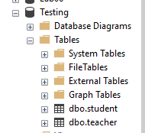
Each table have attributes of Name, age, address and phone numbers.
Response:
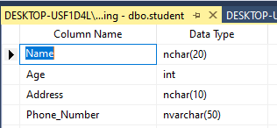

Showing the entered data

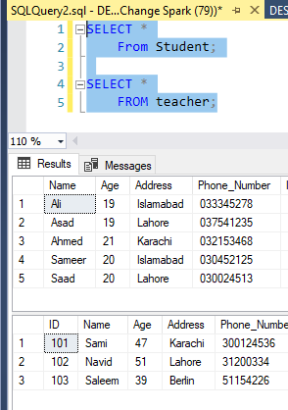
2. Now adding country in both tables and then showing the records

